User guide
jWebSocket
C# Client Library
Version 1.0

Version Control
Date | Version | Description | Author
12/02/2012 | 1.0 | Creation of the document | Rolando Betancourt Toucet

- Characteristics of the solution

The client library for developing applications with the framework jWebSocket using the programming language C Sharp, is only a collection of classes and functions that provide a well-defined interface and structured to manage communication between a client application and the framework jWebSocket work. It is useful for the community of developers using the programming language C Sharp, because using this library can focus on application logic without losing time in the protocol implementation WebSocket to achieve communication with the framework.

2. Main functionalities
- Start the connection with the jWebSocket framework.
- Allow exchange data the jWebSocket framework.
- Terminate the connection with the jWebSocket framework.
The C Sharp Client Library can be used by any developer or institution wishing to make an application. NET using the programming language C Sharp and pretend to integrate with the framework jWebSocket. You can develop desktop applications or both console and web applications developed using ASP .NET.
3. Problems to be solved
Problem | Contributions of the solution
C# apps up to now cannot communicate with browser or mobile apps. | Full integration between client applications developed using this library and the jWebsocket framework. Communication is achieved with all browsers and devices that use technology jWebSocket.

4. Glossary
Real Time Web: It is possible when the client receives messages from the server without prior request and end users receive updates simultaneously.

WebSocket: It is a technology that provides a bidirectional communication channel and full-duplex over a single TCP socket. This protocol solves the limitations of HTTP, by establishing a full-duplex communication (TCP) between the client and server, replacing the half-duplex communication (HTTP). Is reduced, in large proportions, the network traffic given that WebSocket to establish communication between the client and the server there is only one overhead of 2 bytes, eliminating the HTTP headers.

Framework jWebSocket: Is a new technology oriented to developing WebSockets based applications that provide high levels of speed, scalability, security and work in real time.
Client library: It's an application programming interface (API) used to write client applications. Provides generic building blocks for building client applications.

5. Model of solution

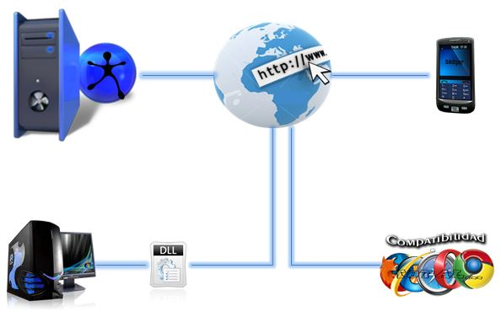
Picture 1: Model of the solution

For a client application can communicate with the jWebSocket server only needs use the C Sharp client library to manage the communication between the application and the server.
6. Requirements for Use
Must have .NET Framework 4.0 on the PC where the application runs.
7. Roles de la solución
Application User: Interacts with the application, you can perform all actions that provide the same.

8. System Operation
C Sharp client library contains a well-defined API that provides multiple functionalities to the user. For example:

C Sharp Client library API
Methods | Description
public WebSocketBaseTokenClient() | Build a base token.
public WebSocketBaseTokenClient( WebSocketReliabilityOptions aReliabilityOptions) | Build a base token whit reliability option.
public void SendTokenText(Token aToken) | Send token text
public void SendTokenText(Token aToken, WebSocketResponseTokenListener aResponseListener) | Send token text and wait for answer.
private void SendTokenBinary(Token aToken) | Send token binary.
private void SendTokenBinary(Token aToken, WebSocketResponseTokenListener aResponseListener) | Send token binary and wait for answer.
public void AddTokenClientListener( WebSocketClientTokenListener aTokenListener) | Add listeners to the application.
Public void RemoveTokenClientListener( WebSocketClientTokenListener aTokenListener) | Remove listeners to the application.
public Dictionary<string, string> GetRequestHeader() | Gets the header of the request.
public Dictionary<string, string> GetResponseHeader() | Gets the header of the response.
public void Close() | Finish the connection to the server.
public bool IsRunning() | Determines if the application is running.

Application demo
The C Sharp Client Demo demo to test the functionality of the client library C Sharp in a client application. This application allows to create a connection to the jWebSocket Framework, provides the possibility to send messages, select options reliability, start section, close section and disconnect from the server. The following shows a list of its features and a demo picture.

- Field to enter the URL of the server you want to connect.
- Button to open a new connection (not open new section).
- Button to close the connection (not close section).
- Choose the options of reliability when the connection to the server.
- This field allows you to specify the waiting time to reconnect with the server.
- This field lets you specify the delay time to reconnect with the server.
- Field to enter the message you want to send.
- Button that allows sending messages to the server.
- Button that allows you to clean traces of operations.
- Button to start a connection (opens new section).
- Button to terminate a connection (closed section).

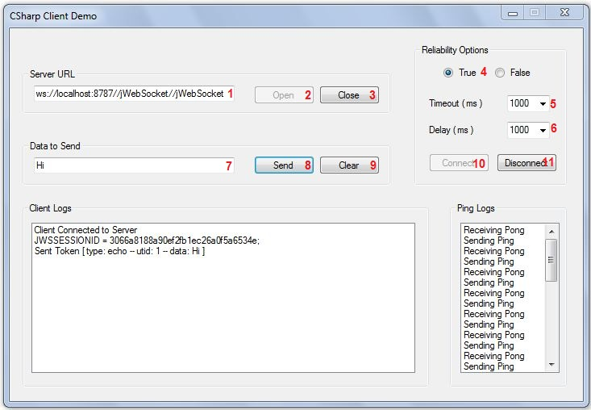

You can download this demo at the following address:
https://jwsdev.org:9443/svn/jWebSocket/branches/jWebSocket-1.0/jWebSocketCSClient/Demos/ClientDemo

9. Configurations of solution
It contains a file named config.xml in which you can change aspects of its operation.

